Mimi,

Here are four articles that I hope are not too late for next month’s Somos Primos.

The following are recent events in which the San Antonio Chapter Granaderos y Damas de Gálvez participated.

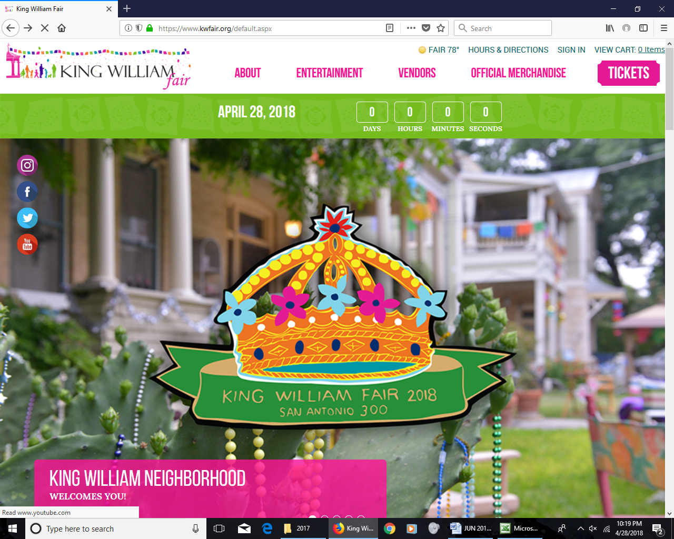

On the morning of Saturday, April 28th, we once again served as the Vanguard in the King William Parade, which is an offical Fiesta San Antonio event. Our entry this year was the largest we have ever had with over 30 people representing various time periods. We had seven flags of Texas up front followed by 1718 presidial soldiers and a Franciscan friar. That was followed by our Fife & Drum Corps, our Color Guard and our musket-carrying Granaderos. Militia members filled out our entry, which was over two blocks long. We thank Ricardo Rodriguez and Charles Lara of the Alamo Legacy & Missions Association for partnering with us this year to provide the best parade entry we have ever had.

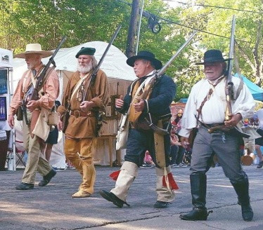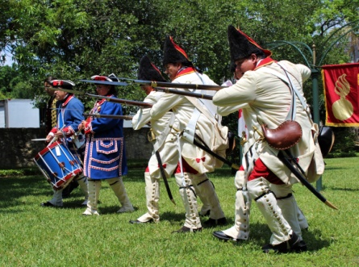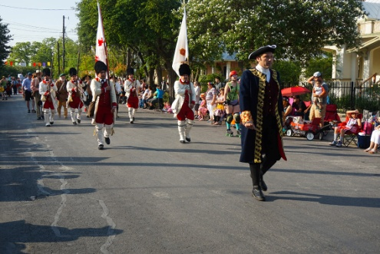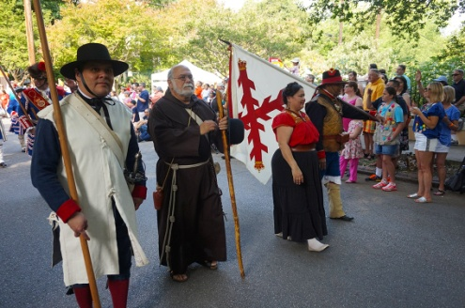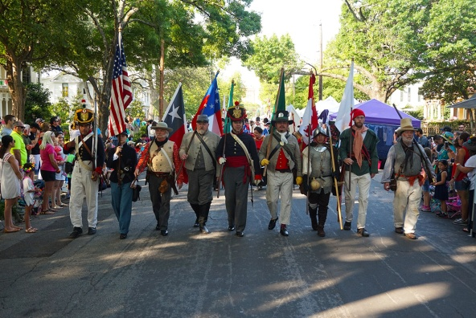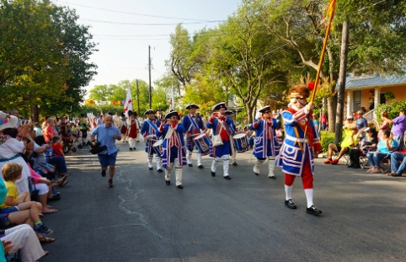

**San Pedro Creek Park**

**Grand Opening**

On Saturday, May 5th, we participated in a presentation by the Canary Islands Descendants Association at the Grand Opening of the San Pedro Creek Park, which was a San Antonio Triecentennical Parnter Event. We served as Color Guard and played five tunes prior to the presentation that honored the twelve families from the Canary Islands that formed the first civil government in San Antonio in 1731. We thank the Canary Islands Descendants Association for inviting us to this wonderful event.

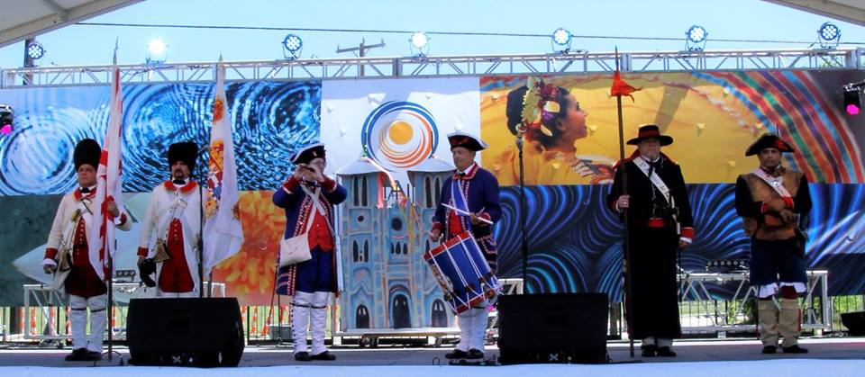

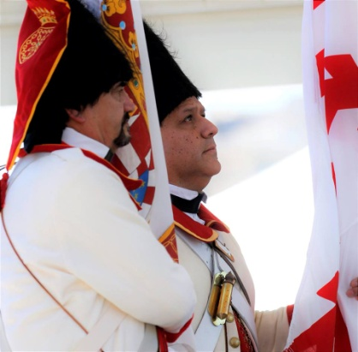

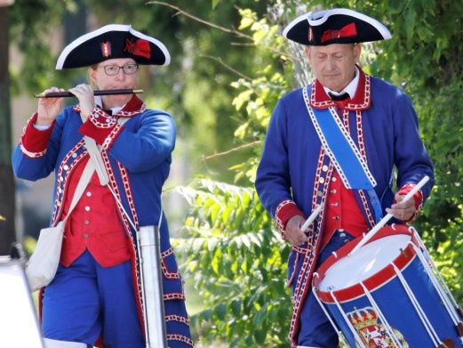

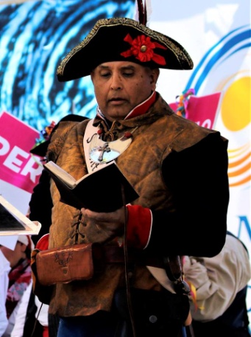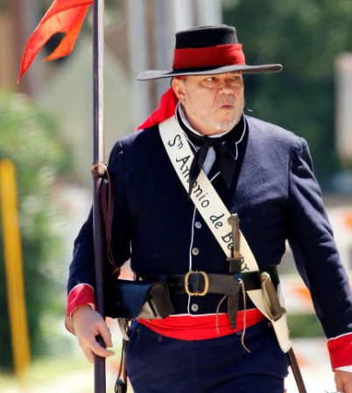

U.T. Health S.A.

On Saturday, May 12th, we served as Color Guard for a Tricentennial Partner Event at the U.T. Health San Antonio campus celebrating 300 years of history and advances in health in San Antonio. We thank Dr. Chiscano for inviting us to perform. We presented the Colors, marching in and out to Spanish Colonial tunes by our fifers and drummers

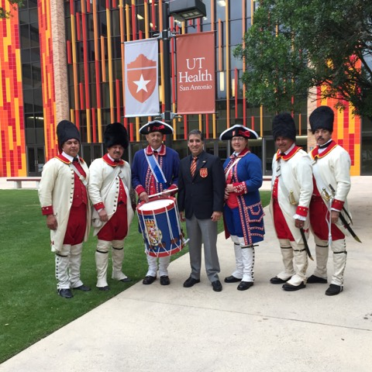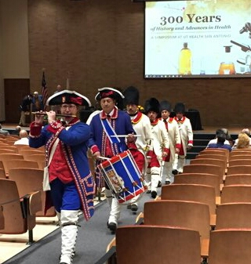



**NEW BOOK ON BERNARDO DE GALVEZ**

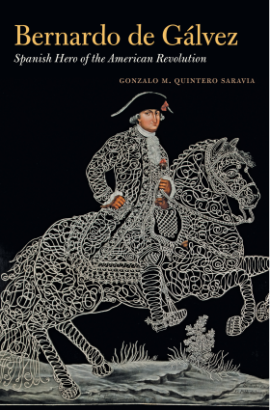

A new book,issused in May by the University of North Carolina Press, is titled Bernardo de Gálvez, Spanish Hero of the American Revolution by author Gonzalo M. Quintero Saravia. The University of North Carolina Press currently has an American History Sale on certain books on history, this being one of them. You can now order this book from UNC Press for 40% off at uncpress.org. Below is the press release from the UNC Press.

Although Spain was never a formal ally of the United States during the American Revolution, its entry into the war definitively tipped the balance against Britain. Led by Bernardo de Gálvez, supreme commander of the Spanish forces in North America, their military campaigns against British settlements on the Mississippi River—and later against Mobile and Pensacola—were crucial in preventing Britain from concentrating all its North American military and naval forces on the fight against George Washington’s Continental army. In this first comprehensive biography of Gálvez (1746@–86), Gonzalo M. Quintero Saravia assesses the commander’s considerable historical impact and expands our understanding of Spain’s contribution to the war.

A man of both empire and the Enlightenment, as viceroy of New Spain (1785@–86), Gálvez was also pivotal in the design and implementation of Spanish colonial reforms, which included the reorganization of Spain’s Northern Frontier that brought peace to the region for the duration of the Spanish presence in North America. Extensively researched through Spanish, Mexican, and U.S. archives, Quintero Saravia’s portrait of Gálvez reveals him as central to the histories of the Revolution and late eighteenth-century America and offers a reinterpretation of the international factors involved in the American War for Independence.